FitTrack AI – Personalized Fitness Recommendations Powered by AI
PROJECT DESCRIPTION:
FitTrack AI is an AI-powered backend application developed using Node.js, Express.js, MongoDB, Mongoose, and Google Gemini AI. The system helps users manage workout records and receive personalized fitness guidance.
The application provides secure user registration and login using JWT authentication and bcrypt.js password hashing. Authenticated users can add, view, search, update, and delete workout records.
Google Gemini AI is used to generate personalized workout recommendations based on the user’s age, fitness goal, and experience level. It also provides fitness insights by analyzing workout statistics such as total workouts, average workout duration, and calories burned.
SCENARIO:
Problem:
Many users track their workouts manually using notebooks or spreadsheets. This makes it difficult to maintain workout history, search previous workouts, and monitor fitness progress. Users may also find it difficult to choose suitable workouts according to their fitness goals and experience level. Manual tracking can also make it harder to understand workout duration and calories burned. AI FitTrack
AI Solution:
FitTrack AI provides a centralized backend system where users can securely register, log in, and manage workout records. Users can add, view, search, update, and delete workouts through REST APIs. Google Gemini AI provides personalized workout recommendations based on age, fitness goal, and experience level. The system also generates fitness insights using workout statistics such as total workouts, average workout duration, and calories burned.
Impact:
FitTrack AI makes workout tracking easier, more organized, and more secure. It reduces manual record keeping and allows users to maintain workout history efficiently. The AI features provide personalized recommendations and useful fitness insights that help users understand their workout activities better.
SYSTEM REQUIREMENTS:
FitTrack AI requires suitable software and hardware resources for backend development, local database management, AI integration, and API testing.
1. Software Requirements
Operating System: Windows 10/11 is used for development and execution.
Node.js: Provides the runtime environment for executing backend JavaScript code.
Express.js: Used to create REST APIs, manage routes, process requests, and return responses.
MongoDB Community Server: Used as the local NoSQL database for storing user and workout information.
MongoDB Compass: Used to view and manage the local MongoDB database.
Mongoose: Used for schema definition, validation, and communication between Node.js and MongoDB.
Google Gemini AI: Used to generate personalized workout recommendations and fitness insights.
Thunder Client: Used to test REST APIs inside Visual Studio Code.
Visual Studio Code: Used for project development, execution, and testing.
2. Hardware Requirements
Processor: Intel Core i5 / AMD Ryzen 5 or equivalent.
RAM: Minimum 8 GB recommended.
Storage: At least 1 GB free space.
Internet Connection: Required for Google Gemini AI.
Display: 1366 × 768 resolution or higher is recommended.
PROJECT ARCHITECTURE:
FitTrack AI follows a modular backend architecture. Different parts of the application are separated according to their responsibilities, which makes the system easier to manage and maintain. Node.js and Express.js handle backend processing, MongoDB stores user and workout data locally, Mongoose manages database operations, and Google Gemini AI provides workout recommendations and fitness insights.
Technical Architecture:
1. Backend Layer
The backend receives requests from the user, processes application logic, and returns JSON responses. It handles registration, login, profile access, workout management, workout search, AI recommendations, and fitness insights.
2. Database Layer
MongoDB Community Server is used to store user and workout information locally. MongoDB Compass is used to view and manage the database, while Mongoose is used to define schemas and perform database operations.
3.Authentication Layer
JWT authentication is used to verify logged-in users and protect private API routes. bcrypt.js is used to hash user passwords before storage.
4. Workout Management Layer
Authenticated users can add, view, retrieve, search, update, and delete workout records.
5. AI Layer
Google Gemini AI generates personalized workout recommendations based on age, fitness goal, and experience level. It also provides fitness insights using workout statistics.
6. API Testing Layer
Thunder Client is used to test the major APIs including Register, Login, Profile, Workout CRUD, Workout Search, Workout Recommendation, and Fitness Insights.
Architecture Flow:
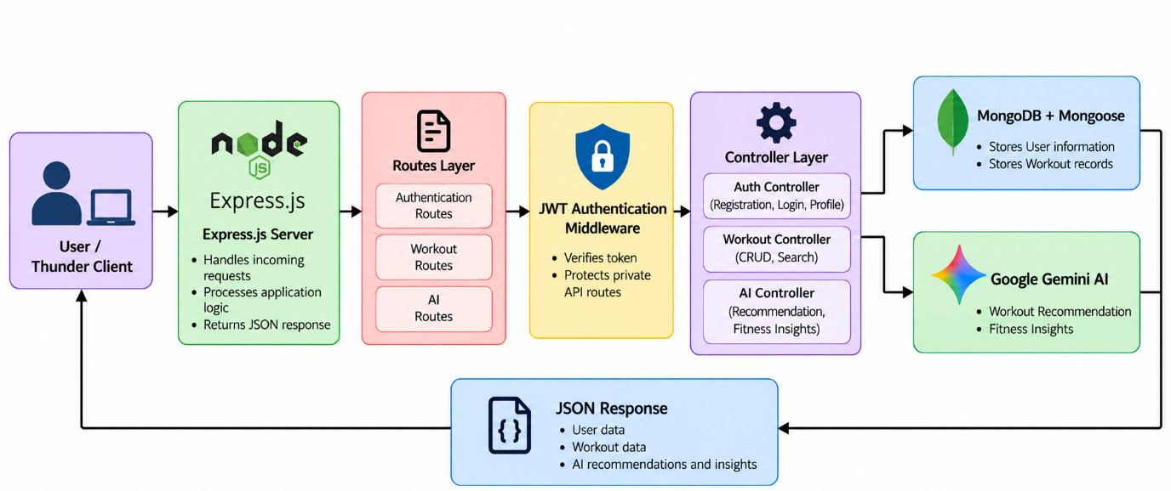
ER DIAGRAM:
The Entity-Relationship Diagram of FitTrack AI represents the database structure used to store registered user information and workout records. The project mainly uses two entities: User and Workout. MongoDB is used as the local database, while Mongoose is used to define the schemas and manage database operations.
User Entity:
The User entity stores the details of registered users.
Main attributes:
- _id – Unique identifier for each user
- name – Name of the user
- email – Registered email address
- password – Password stored in hashed form
- createdAt – Account creation date and time
- updatedAt – Last updated date and time
Location Entity:
The Workout entity stores workout records created by authenticated users.
Main attributes:
- _id – Unique identifier for each workout
- user – Reference to the user who created the workout
- workoutName – Name of the workout
- category – Type of workout
- duration – Workout duration in minutes
- caloriesBurned – Number of calories burned
- workoutDate – Date of the workout
- createdAt – Record creation date and time
- updatedAt – Last updated date and time

\

ER Representation:

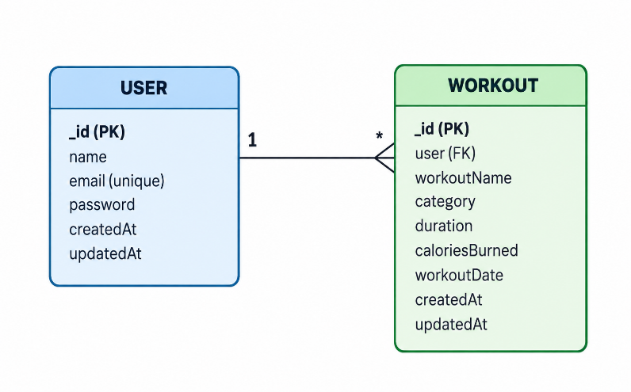

Explanation:
A one-to-many relationship exists between the User and Workout entities. One registered user can create multiple workout records, while each workout belongs to only one user. The user field in the Workout collection stores the ObjectId reference of the corresponding user. This allows workout records to be managed separately for each authenticated user.
FEATURES:
FitTrack AI provides secure backend functionality, workout management, workout search, and AI-powered fitness guidance.
Core Backend Features:
User Registration:
Allows new users to create an account using their name, email address, and password.
User Login:
Registered users can log in using email and password. After successful authentication, a JWT token is generated.
JWT Authentication:
JSON Web Tokens are used to verify authenticated users and protect private API routes.
Password Hashing:
User passwords are securely hashed using bcrypt.js before being stored in MongoDB.
User Profile:
Authenticated users can view their profile information.
Workout Management:
Users can add, view, update, and delete workout records.
Get Workout by ID:
A specific workout can be retrieved using its unique ID.
Workout Search:
Users can search workout records using the q query parameter.
MongoDB Integration:
MongoDB stores user and workout information locally.
REST API Support:
The application uses HTTP methods such as GET, POST, PUT, and DELETE for backend operations.
AI Features:
AI Workout Recommendation:
Google Gemini AI generates personalized workout recommendations based on the user’s age, fitness goal, and experience level.
AI Fitness Insights:
The AI analyzes workout statistics such as total workouts, average duration, and calories burned to provide useful fitness guidance.
AI-Powered Fitness Guidance:
Workout information is converted into simple recommendations and insights that help users understand their fitness activities better.
ROLES AND RESPONSIBILITIES
Registered User
The registered user can create an account, log in securely, view profile information, manage workout records, search workouts, and receive AI-generated workout recommendations and fitness insights.
System / Backend
The backend manages the complete operation of FitTrack AI. It handles user registration and login, verifies JWT tokens for protected routes, stores user and workout information in MongoDB, and performs workout operations such as add, view, search, update, and delete. It also communicates with Google Gemini AI to generate personalized workout recommendations and fitness insights, and returns the results to the user in JSON format.
USER FLOW
The user flow explains how a user interacts with FitTrack AI from account creation to workout management and AI-based fitness guidance.
- User Registration – A new user creates an account using name, email, and password.
- User Login – The registered user logs in using email and password.
- JWT Authentication – The backend generates a JWT token after successful login.
- View Profile – The authenticated user can view profile information.
- Add Workout – The user creates a workout record with workout details.
- Manage Workouts – The user can view, update, and delete workout records.
- Search Workouts – The user can search workout records using a search term.
- Workout Recommendation – The user provides age, fitness goal, and experience level to receive a personalized workout recommendation.
- Fitness Insights – The system analyzes workout statistics and provides AI-generated fitness insights.
- Return Response – The backend returns workout data, recommendations, or fitness insights in JSON format.

User Flow Representation:
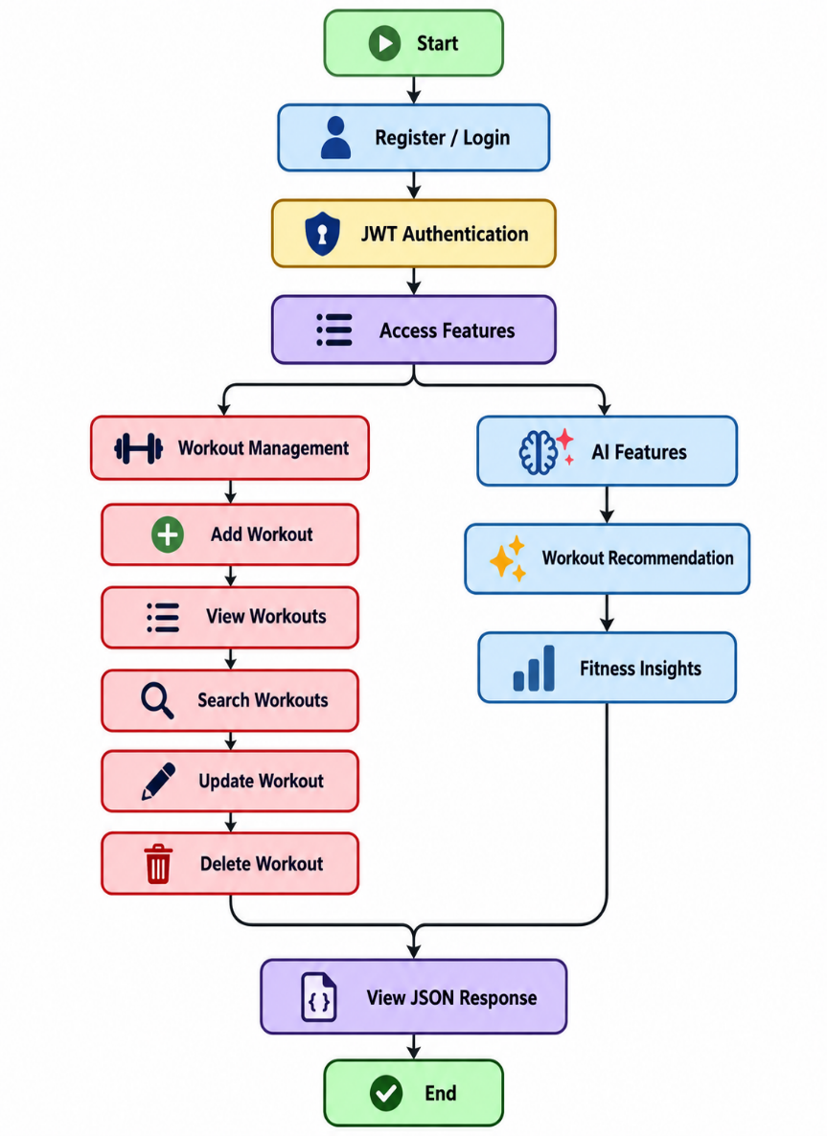
MVC PATTERN:
FitTrack AI follows a modular Model-View-Controller (MVC) based backend structure. The application separates data handling, business logic, API routes, middleware, and AI services into different components. This improves code organization, maintenance, and scalability.
Model Layer
The Model Layer defines the structure of data stored in MongoDB using Mongoose.
Main models:
User.js
- Stores user information such as name, email, password, and timestamps.
Location.js
- Stores workout information such as workout name, category, duration, calories burned, workout date, user reference, and timestamps.
Controller Layer
The Controller layer contains the main business logic.
authController.js – Handles user registration, login, profile retrieval, JWT generation, and password verification.
workoutController.js – Handles workout creation, retrieval, search, update, and delete operations.
aiController.js – Handles AI workout recommendations and fitness insights.
Routes Layer
The Routes Layer defines the API endpoints and forwards requests to the appropriate controllers.
- authRoutes.js – Authentication and profile routes
- workoutRoutes.js – Workout CRUD and search routes
- aiRoutes.js – Workout recommendation and fitness insight routes
Service Layer
The Service Layer handles reusable logic and communication with Google Gemini AI for generating workout recommendations and fitness insights.
Middleware Layer
The authentication middleware verifies JWT tokens and protects private APIs from unauthorized access. AI FitTrack
Advantages of MVC
The modular structure makes the project easier to understand, debug, maintain, and extend with additional features in the future.
PROJECT SETUP AND CONFIGURATION:
FitTrack AI is organized as a modular backend project using Node.js and Express.js. The project separates configuration, controllers, models, routes, middleware, and services so that each component has a clear responsibility. This makes the backend easier to maintain and extend.

Project Structure
The backend project contains the main folders and files required for authentication, workout management, AI integration, middleware, database configuration, and server execution.
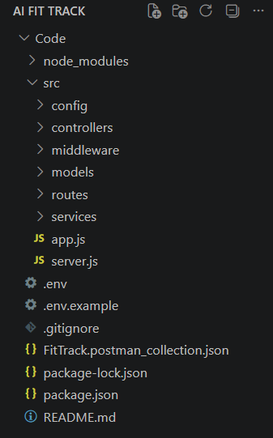
Project Initialization
The project was initialized using npm.
npm init -y
This command creates the package.json file, which stores project details, scripts, and dependencies.
Installation of Backend Packages
The required packages were installed using npm.
npm install
These packages support Express APIs, MongoDB connectivity, authentication, password hashing, environment variables, and AI integration.
Environment Configuration
Sensitive information such as database credentials, JWT secrets, and API keys is stored in the .env file.
PORT=5000
MONGO_URI=mongodb://localhost:27017/FitTrackAI
JWT_SECRET=your_jwt_secret
GEMINI_API_KEY=your_gemini_api_key
The .env file contains the actual configuration values used by the project, while .env.example can be used as a sample template without exposing real secrets.
BACKEND DEVELOPMENT
The FitTrack AI backend is developed using Node.js and Express.js. It manages user authentication, workout operations, workout search, and AI-generated fitness guidance. MongoDB is used for local data storage, while Google Gemini AI is used to generate personalized workout recommendations and fitness insights.
Authentication API
The authentication module manages user registration, login, and profile access. During registration, the user provides a name, email address, and password. The password is hashed using bcrypt.js before being stored in MongoDB. During login, the entered password is verified with the stored hashed password. If the credentials are valid, the backend generates a JWT token for authentication.
JWT Authentication
JWT authentication is used to secure protected API routes.
After successful login, the JWT token is sent in the Authorization header:
Authorization: Bearer <JWT_TOKEN>
The authentication middleware verifies the token before allowing access to protected APIs such as workout management and AI features.
Workout CRUD API
The Workout module allows authenticated users to manage workout records.
Supported operations are:
POST /api/workouts
GET /api/workouts
GET /api/workouts/:id
PUT /api/workouts/:id
DELETE /api/workouts/:id
These APIs allow users to add, view, retrieve, update, and delete workout records. Workout Search API
FitTrack AI also provides workout search functionality.
The search endpoint is:
GET /api/workouts/search?q=searchterm
The user enters a search term using the q query parameter, and the backend returns matching workout records.
Gemini AI Integration
Google Gemini AI is integrated with FitTrack AI to provide intelligent fitness guidance.
The project provides two AI functions:
Workout Recommendation: Generates personalized workout suggestions based on age, fitness goal, and experience level.
Fitness Insights: Analyzes workout statistics and provides useful fitness guidance and improvement suggestions.
Purpose of Gemini API
The Gemini API is used to interpret raw weather values and generate meaningful weather insights. This makes the weather information easier for users to understand and apply to their daily activities.
Security Practices:
Sensitive information such as JWT secrets and Gemini API keys is stored in environment variables.
JWT authentication protects private routes, while bcrypt.js is used to securely hash user passwords.
DATABASE DEVELOPMENT
FitTrack AI uses MongoDB Community Server as the local NoSQL database. MongoDB Compass is used to view and manage the stored data, while Mongoose is used to define schemas, validate data, and perform database operations.
The project mainly uses two collections: Users and Workouts. The Users collection stores registered user information, while the Workouts collection stores workout records created by authenticated users.
PROJECT EXECUTION
The FitTrack AI backend is executed locally using Node.js. Before running the project, the required dependencies and environment variables must be configured correctly.
Step 1 – Install Dependencies
Open the project folder in Visual Studio Code and run:
npm install
This command installs all the packages listed in the package.json file.
Step 2 – Configure Environment Variables
Create or update the .env file with the required configuration values.
PORT=5000
MONGO_URI=mongodb://localhost:27017/FitTrackAI
JWT_SECRET=your_jwt_secret
GEMINI_API_KEY=your_gemini_api_key
The actual keys and credentials should remain private and should not be uploaded to GitHub.
Step 3 – Start MongoDB
Run the backend using:
mongodb://localhost:27017
Step 4 – Start the Backend Server
Run:
npm start
After successful execution, the terminal should show that MongoDB is connected and the server is running.
Server running in development mode on port 5000
MongoDB Connected: localhost
The backend can then be accessed using:
http://localhost:5000

Step 5 – Test the APIs
After the backend starts successfully, the REST APIs are tested using Thunder Client in Visual Studio Code.
The main APIs tested are:
- Register User API
- Login User API
- Get Profile API
- Add Workout API
- Get All Workouts API
- Get Workout by ID API
- Update Workout API
- Search Workout API
- Workout Recommendation API
- Fitness Insights API
- Delete Workout API

OUTPUT SCREENSHOTS:
1. Register API
The Register User API creates a new user account using name, email, and password. The password is hashed using bcrypt.js before being stored in MongoDB.
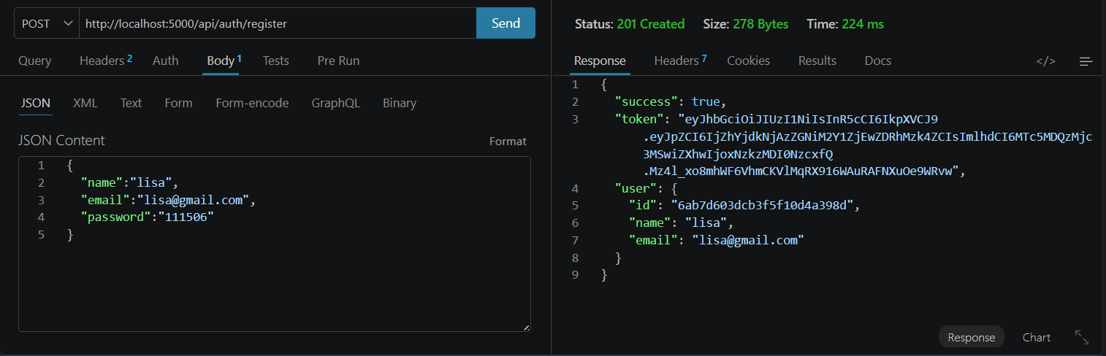
2. Login User API
The Login User API authenticates an existing user using email and password. After successful login, the backend returns a JWT token.
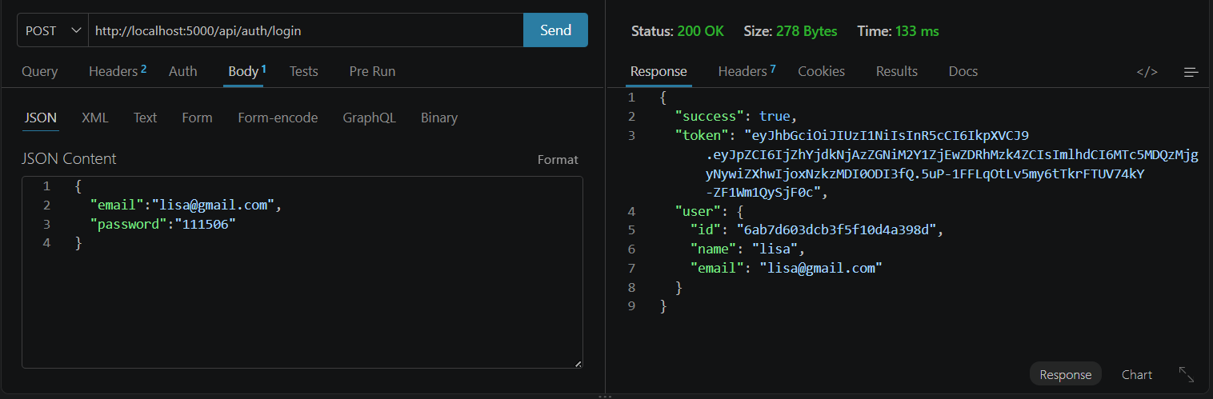
3. Get Profile API
The Get Profile API retrieves the profile information of the currently authenticated user.
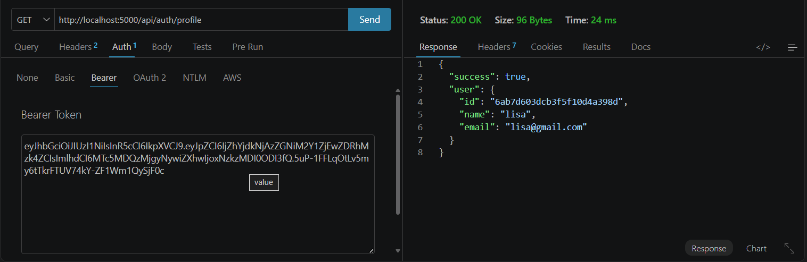
4. Add Workout API
The Add Workout API allows an authenticated user to create a workout record by providing workout name, category, duration, calories burned, and workout date.
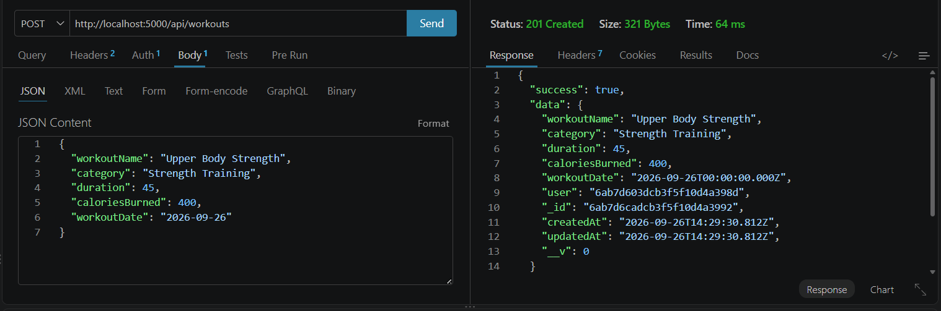
5. Get All Workouts API
The Get All Workouts API retrieves all workout records created by the currently authenticated user.
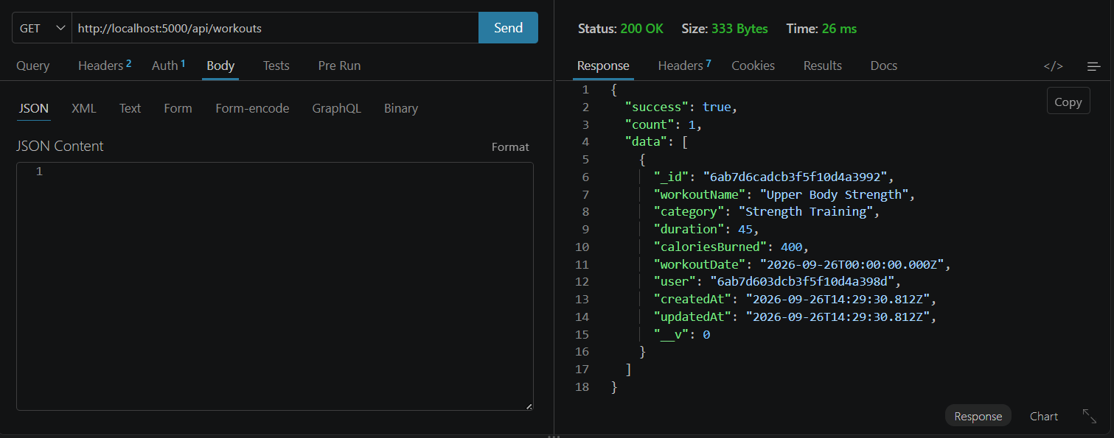
6. Get Workout by ID API
The Get Workout by ID API retrieves a specific workout record using its unique workout ID.
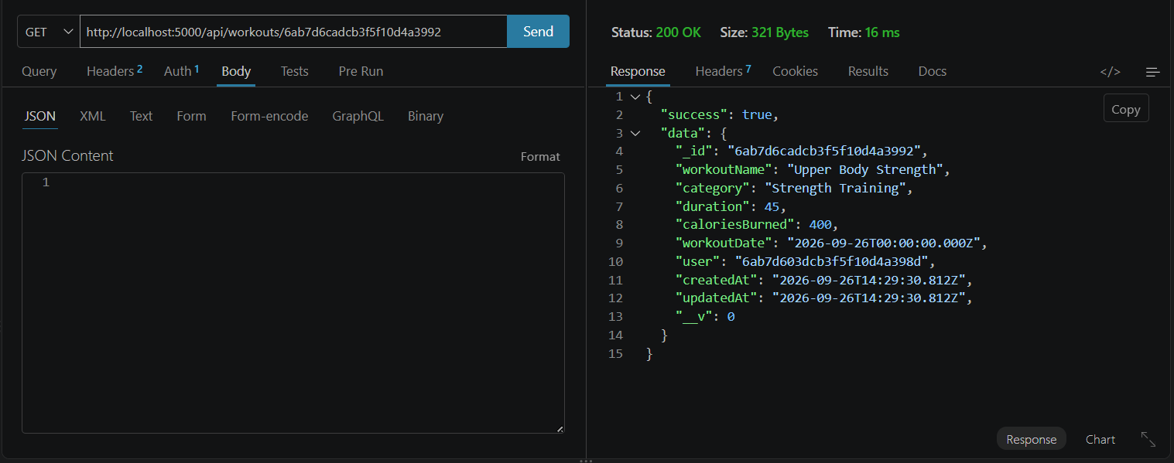
7. Update Workout API
The Update Workout API allows the authenticated user to modify an existing workout record.
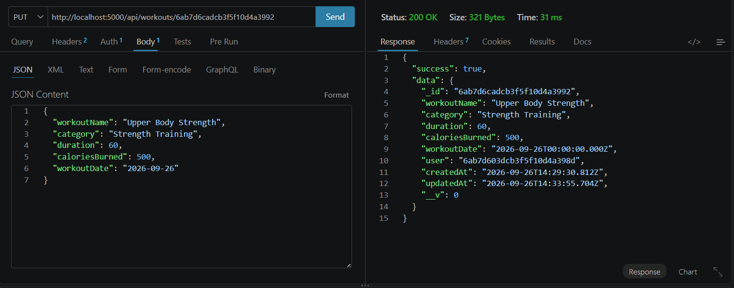
8. Search Workout API
The Search Workout API allows users to search workout records using a search term through the q query parameter.
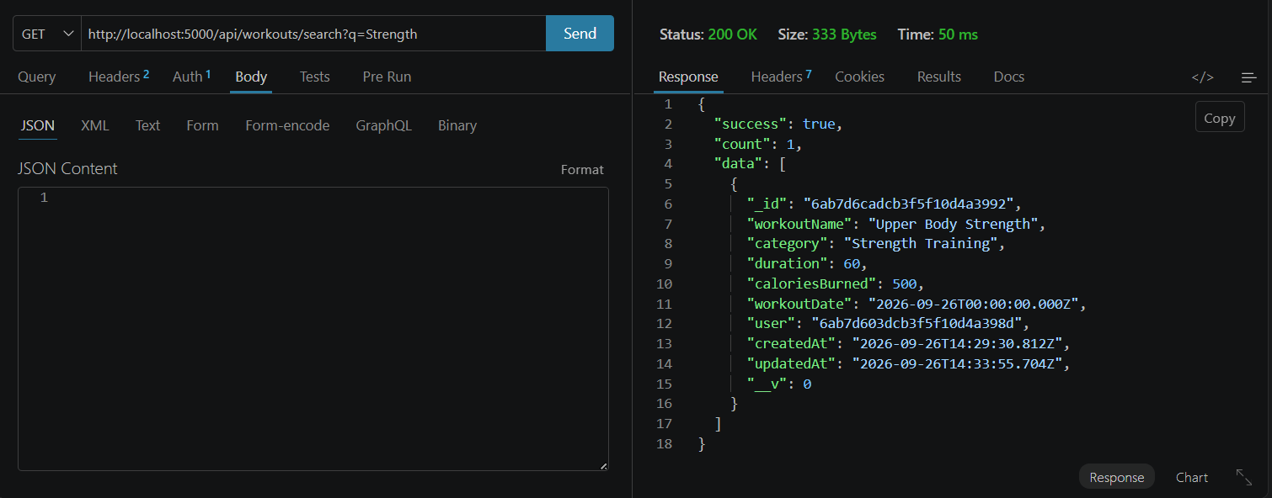
9. Workout Recommendation API
The Workout Recommendation API uses Google Gemini AI to generate personalized workout recommendations based on the user's age, fitness goal, and experience level.
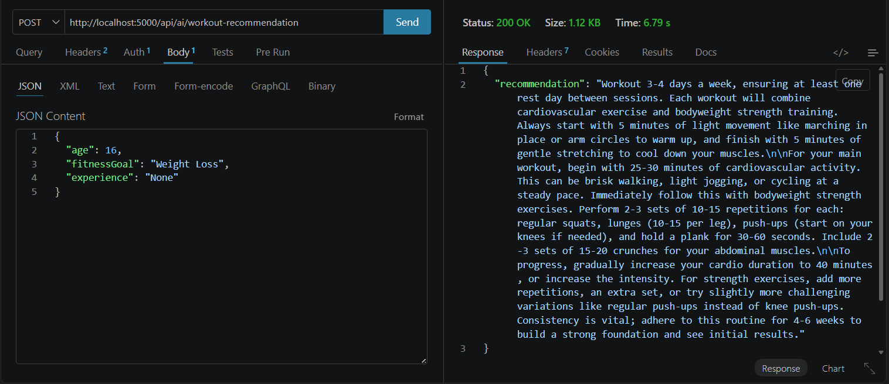
10. Fitness Insights API
The Fitness Insights API uses Google Gemini AI to analyze workout statistics and generate useful fitness guidance and improvement suggestions.
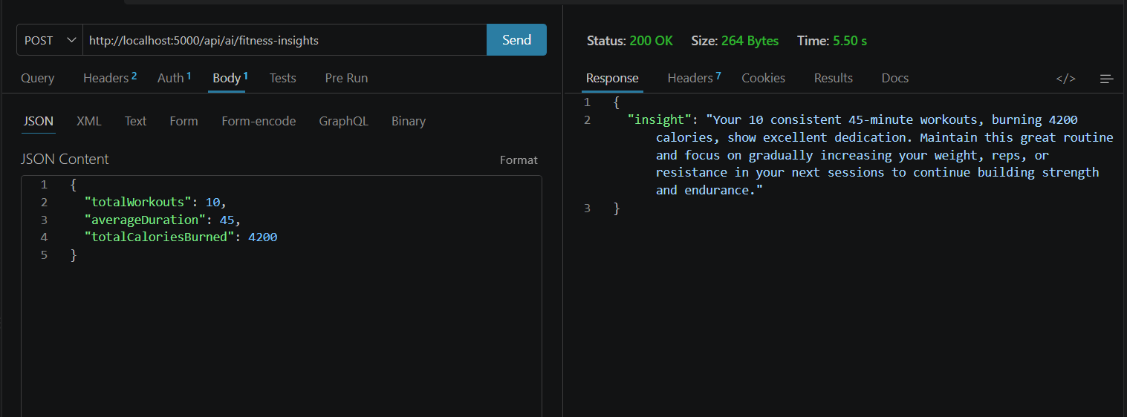
11. Delete Workout API
The Delete Workout API removes the selected workout record from the authenticated user's workout history.
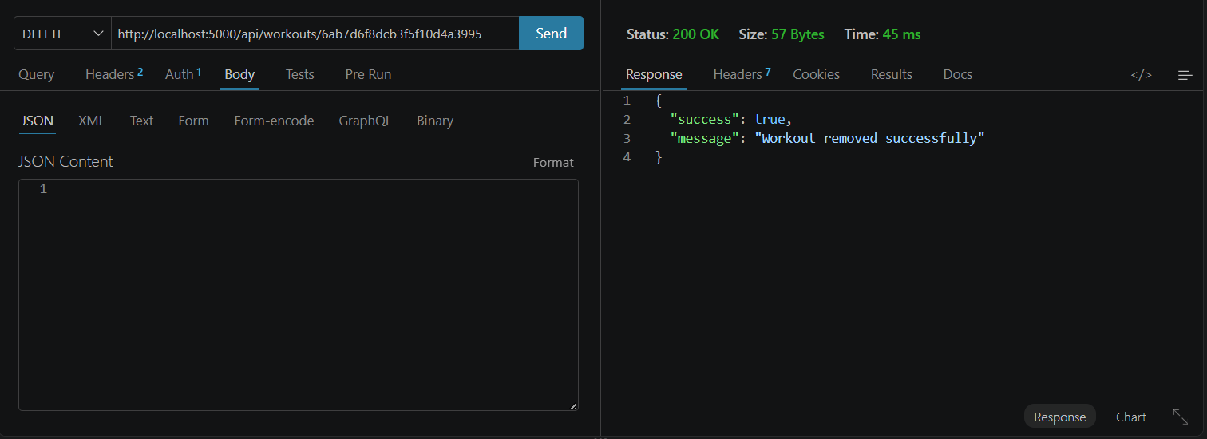

Api Testing Video: Video link
Demo Video: Link
Code : Code link

